ABOUT THE SPEAKER

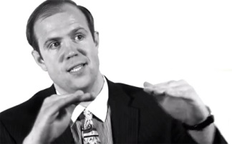
Kalev H. Leetaru - One of Foreign Policy Magazine's Top 100 Global Thinkers of 2013, Kalev is a Senior Fellow at the George Washington University Center for Cyber & Homeland Security and a member of its Counterterrorism and Intelligence Task Force, as well as being a 2015-2016 Google Developer Expert for Google Cloud Platform. From 2013-2014 he was the Yahoo! Fellow in Residence of International Values, Communications Technology & the Global Internet at Georgetown University's Edmund A. Walsh School of Foreign Service, where he was also an Adjunct Assistant Professor. His work has been profiled in Nature, the New York Times, The Economist, BBC, Discovery Channel and the presses of more than 100 nations, while he has been an invited speaker throughout the globe, from the United Nations to the Library of Congress, Harvard to Stanford, Sydney to Singapore. In 2011 The Economist selected his Culturomics 2.0 study as one of just five science discoveries deemed the most significant developments of 2011. Kalev’s work focuses on how innovative applications of the world's largest datasets, computing platforms, algorithms and mind-sets can reimagine the way we understand and interact with our global world. More on his latest projects can be found on his website at http://www.kalevleetaru.com/ or http://blog.gdeltproject.org

